**Name : Sushmita Yadav Batch-1 August 2020**

**Cyber Security-(Assignment 1)**

**Question 1: Find out the mail servers of the following domains :**

**Ibm.com**

**Wipro.com**

**Solution:**

Step 1: To find out the Mail servers 1st type *sudo su* cmd to enter the administrator mode & than we have to use *nslookup* cmd in the terminal/cmd respective of OS.

Step 2: Now to find the mail server we have to use *set type=mx* cmd (where mx denotes Mail Server) and than type the domain name like *Ibm.com* & *Wipro.com* in our case.

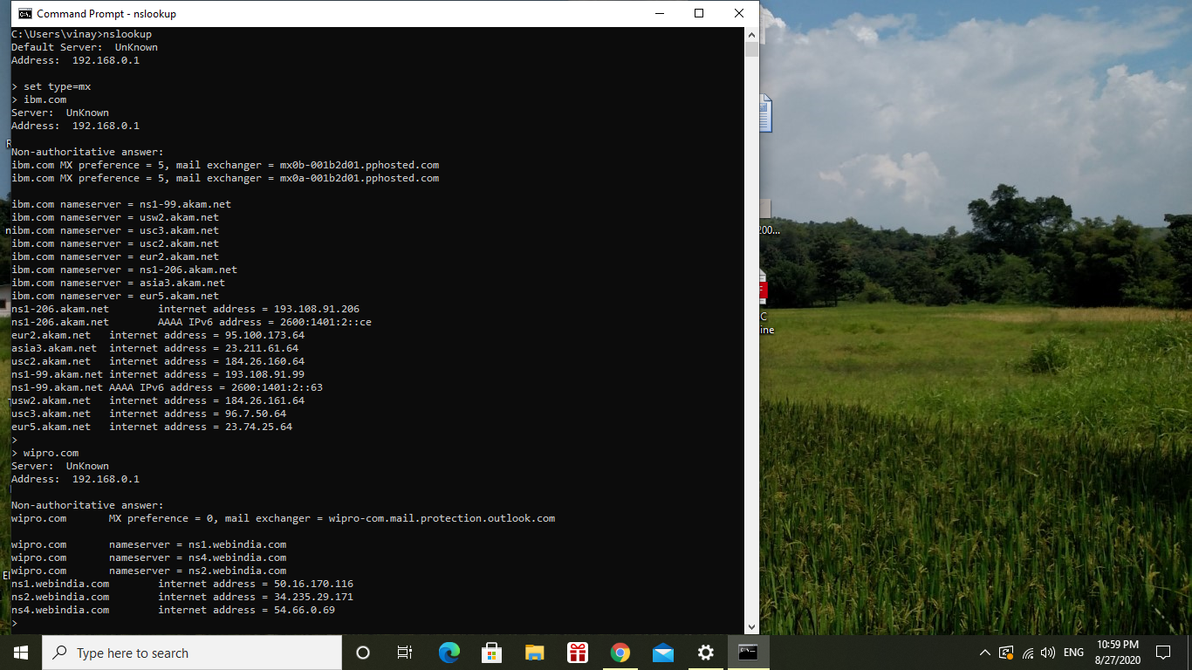

**Question 2: Find the locations, where these email servers are hosted.**

**Solution:**

Step 1: To find out the locations of these Mail servers, as discuss in class we can use eMail Tracker Pro application. But, it will track the mail if we have mail header so here dont have any mail header.

Step 2: So, Now visit the site named as *my-addr.com* and type the mail as [mail@ibm.com](mailto:mail@ibm.com) & [mail@wipro.com](mailto:mail@wipro.com) respectively and cross-check the mailbox domain which we just found in

nslookup.

Location for IBM mail server :

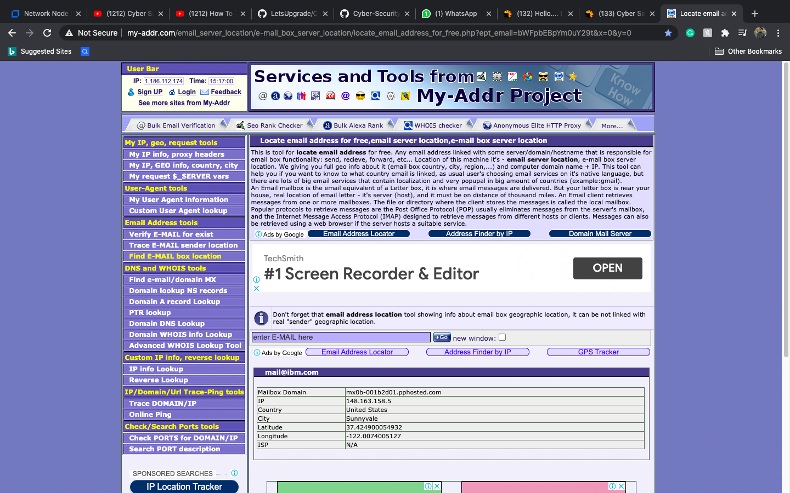

Location for WIPRO mail server :

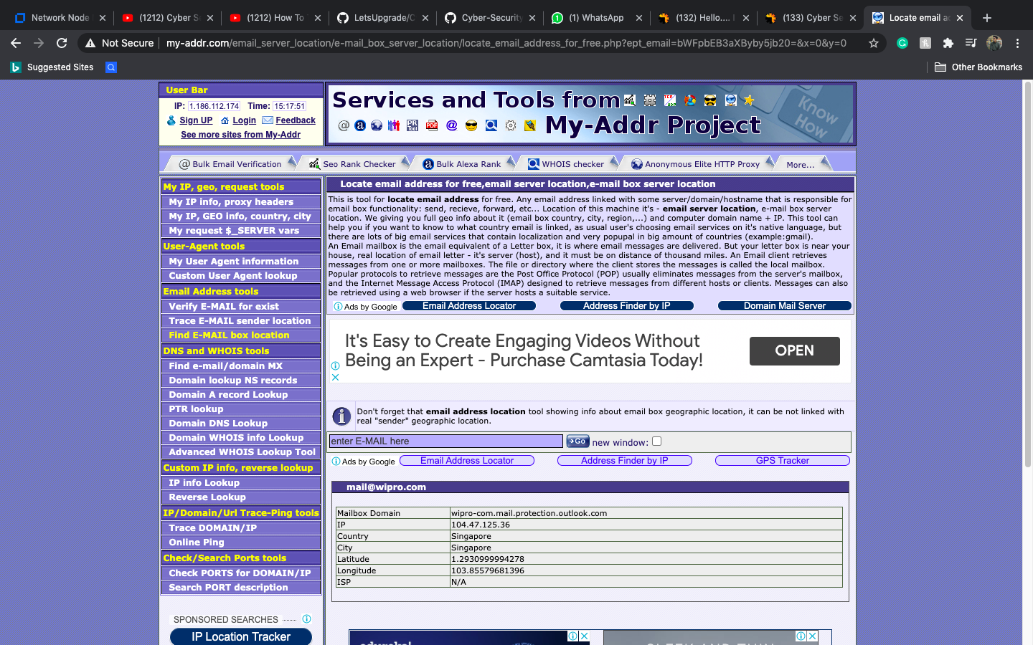

**Question 3: Scan and find out port numbers open 203.163.246.23.**

**Solution:**

Go to Administrator mode and type cmd *nmap -Pn -sS 203.263.246.22-24* as seen below all the port are filtered no open port is found from port 22 to 24.

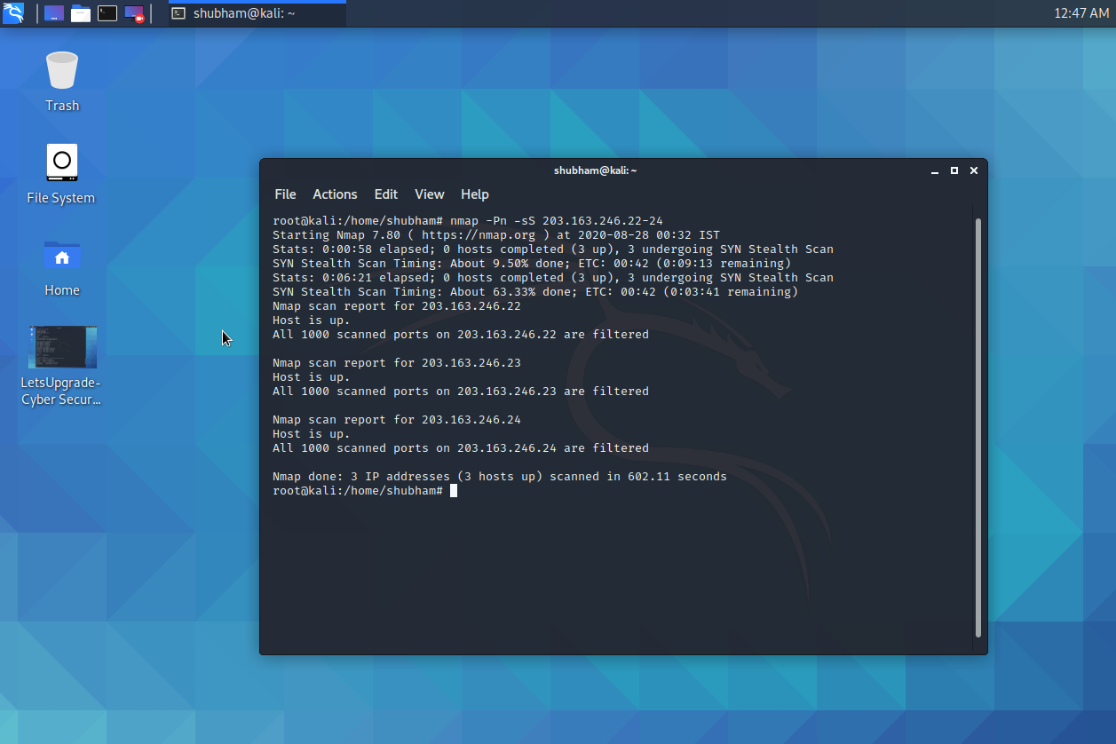

**Question 4: Install nessus in a VM and scan your laptop/desktop for CVE.**

